Q2 Recursive Linear Search (Last Occurrence) — README Report

Project Overview
This project implements a recursive linear search function that finds the last occurrence of a target value in a vector. The implementation modifies the recursion logic so that the search continues to the end of the list before checking earlier elements.
The project contains:
- LinearSearch.h — Function declaration
- LinearSearch.cpp — Implementation of the recursive search
- main.cpp — Demonstration program (optional for testing)
All functionality is implemented as standalone functions, not inside main.
int linear_search_last(vector<int>& items, int& target, size_t pos_index);
To find the last occurrence:
- The function recursively searches forward to the end of the list.
- After reaching the end, the recursion unwinds.
- When unwinding, each earlier index checks if the target was found later.
- If a later index contains the target, that position is kept.
- Otherwise, the current index is returned if it matches.
This reversed checking order guarantees the last occurrence is returned.
How to Compile and Run the Code
Make sure all three files (LinearSearch.h, LinearSearch.cpp, and main.cpp) are in the same folder.

Using g++ (Linux/Mac/Windows MinGW)
g++ main.cpp LinearSearch.cpp -o search_program
./search_program

Using Visual Studio Code
- Install the C/C++ extension.
- Open the folder containing the files.
- Press Run → Run Without Debugging or build using a task.

Using Visual Studio (Windows)
- Create a new C++ Console Application.
- Add LinearSearch.h, LinearSearch.cpp, and main.cpp to the project.
- Press Ctrl + F5 to run.

Expected Output Example
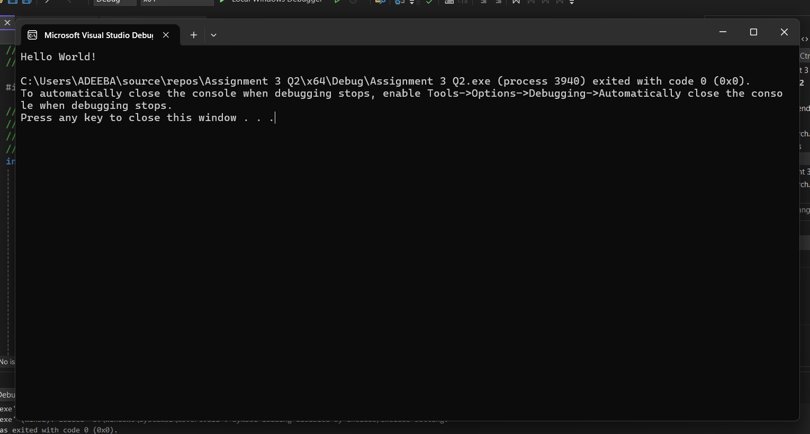

Time Complexity
- Recursion depth: O(n)
- Work done per call: O(1)
- Total complexity: O(n)

Space Complexity
- Due to recursion stack: O(n)

